Customer Policy Registration

**#1**

*Appointment ID: 42*

*Customer Id: CU0001*

*Agent ID: AG0002*

*Policy ID: PO0002*

*Policy Booking Date: 11/03/2018*

*Total Sum: 5000000*

*Payment Mode: Card*

*Commission Type: II*

*Nominee Name: John Doe*

*Nominee Relationship: Son*

*Nominee Date Of Birth: 06/14/2017*

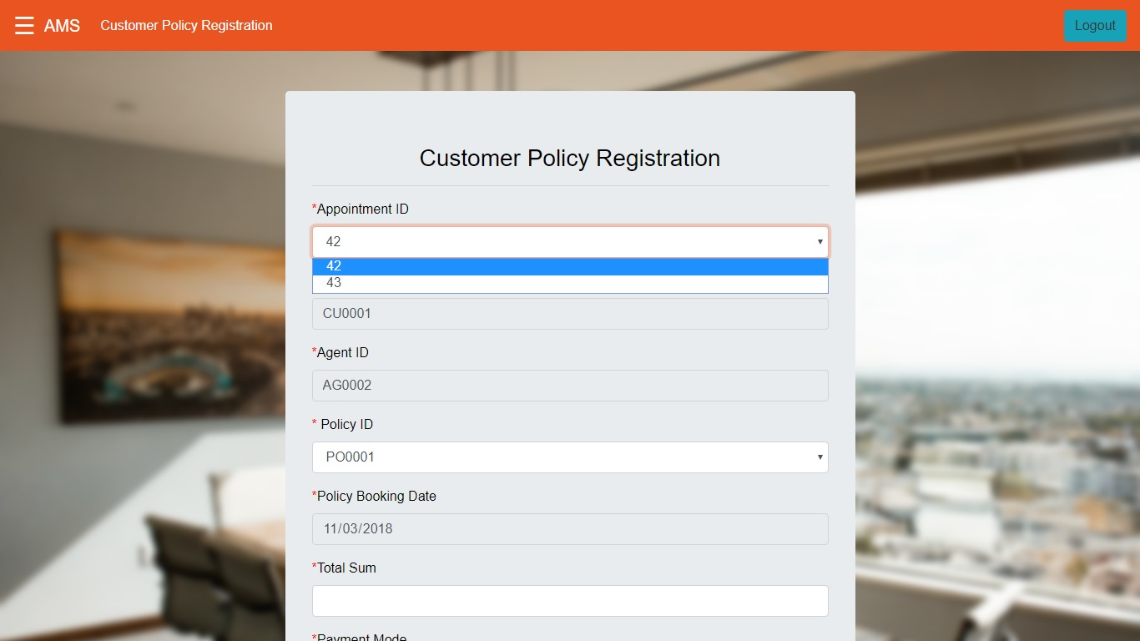

Output:

*Registration Successful*

*The policy has been successfully registered for the customer.*

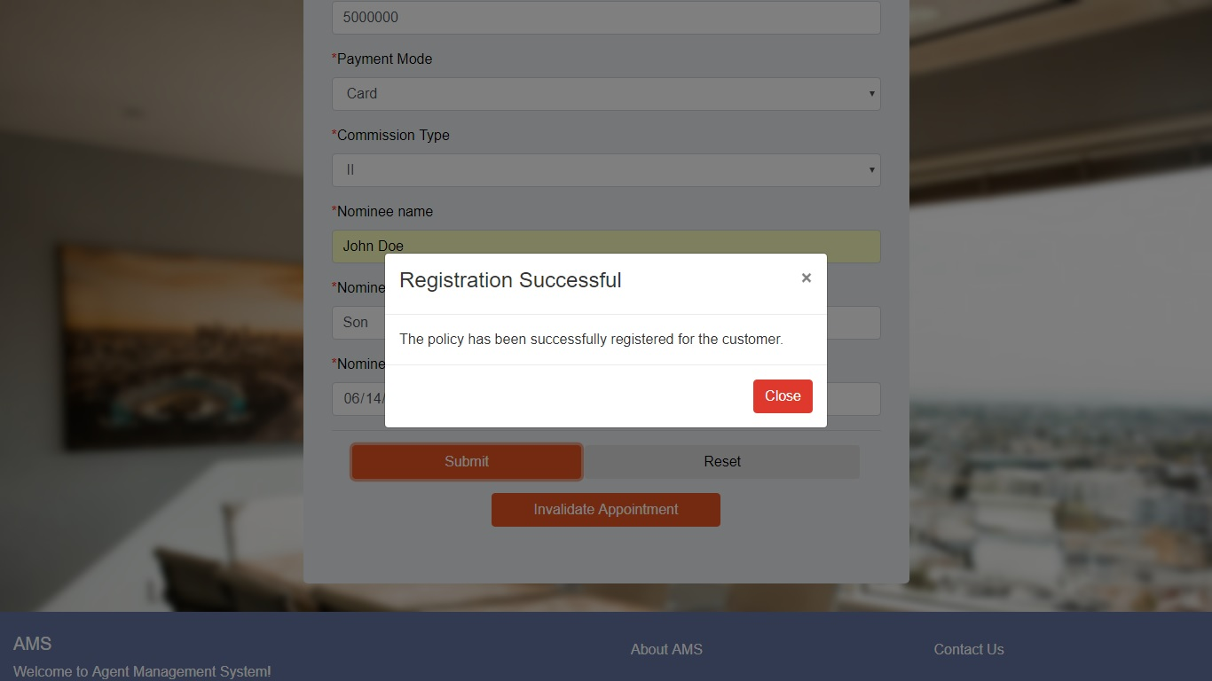

**#2**

*Appointment ID: 43*

*Customer Id: CU0001*

*Agent ID: AG0002*

*Policy ID: PO0003*

*Policy Booking Date: 11/02/2018*

*Total Sum: 599999*

*Payment Mode: Cash*

*Commission Type: I*

*Nominee Name: Manish*

*Nominee Relationship: Father*

*Nominee Date Of Birth: 06/14/1977*

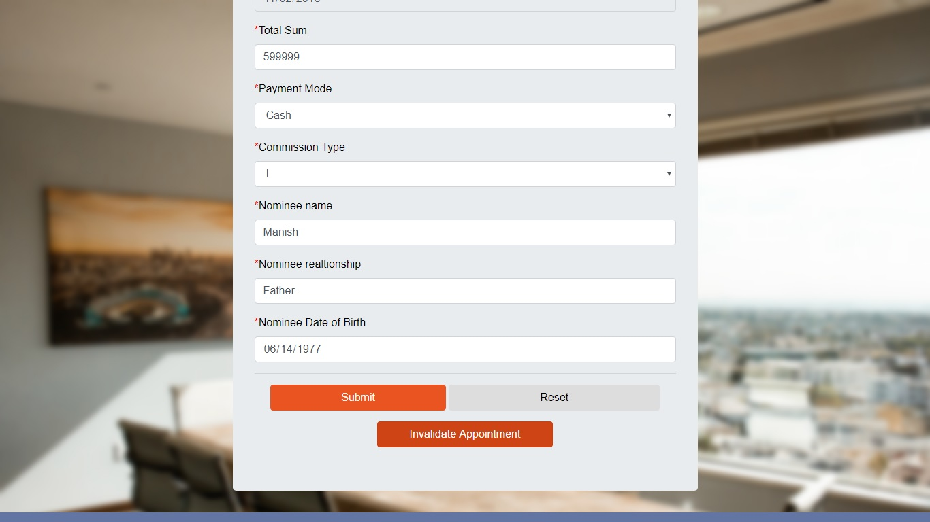

Output:

*Operation Successful*

*Policy with ID 43 has been invalidated!*

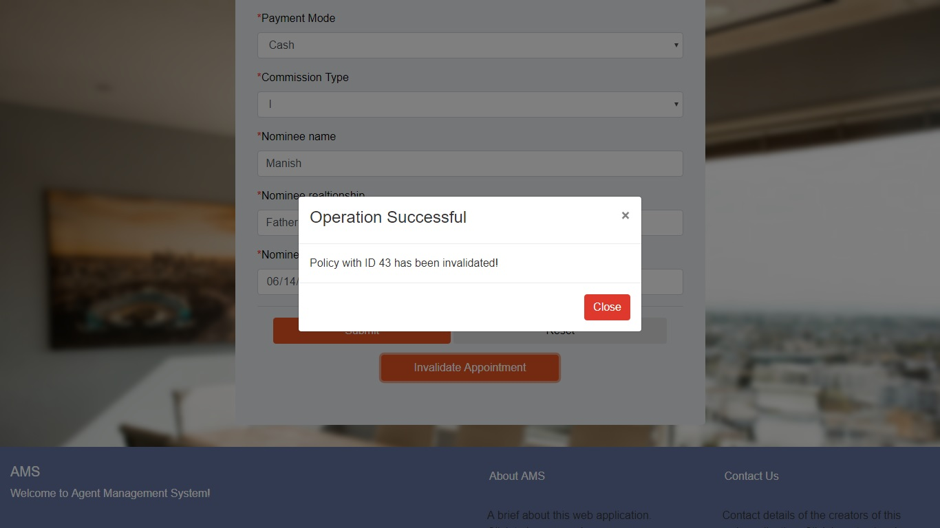

**#3**

When no approvals are pending

Output:

*No Approvals Pending*

*No appointments that are pending for approval exist. Please check this module later.*

